|  |
| --- |
|  |
| CHANGE pathway evaluation form  Date: June 2023  **School and class:**  Multiple choice questions: |

1) What is, at present, the CO2 concentration in atmosphere?

1. About 300 ppm
2. About 400 ppm
3. About 500 ppm

2) What does the acronym “ppm” stand for?

1. Parts per molecule
2. Parts per million
3. Pieces of molecule
4. Pieces of million

3) What are the main causes of the increase in the atmospheric CO2 concentration?

1. The change of seasons
2. Pollution
3. Global warming
4. The CO2 concentration is constant

4) What is the effect of the absorption of IR light by the CO2 molecule?

1. The CO2 molecule starts vibrating, then it releases the absorbed energy in the form of heat
2. It causes the greenhouse effect
3. When the frequency of incident radiation is equal to a characteristic absorption line of the CO2 molecule, the CO2 molecule vibrates in resonance with the incident energy
4. Al the answers are correct

5) What are the main sources of indoor pollution?

1. Cleaning products, furniture
2. Cooking flames, paints
3. Outdoor pollution
4. All the answers are correct

6) What are the main indoor pollutants?

1. VOC, microparticles, CO2
2. VOC, microparticles, formaldehyde
3. Nanoparticles, CO, formaldehyde
4. Nanoparticles, VOC, CO

7) What is the main cause of CO2 concentration increase in a room?

1. Global warming
2. People crowding
3. Air conditioning
4. Paints

8) Which of the following options can reduce the indoor CO2 concentration?

1. Window opening
2. Mechanical ventilation
3. Air change
4. All the options are correct

9) What is the working principle of an optical CO2 sensor work?

1. It compares the velocity of an air flux in two parallel tubes to determine the CO2 concentration
2. It measures the absorption of UV radiation with respect to a reference value to extract the CO2 concentration
3. It measures the intensity of the 4.3 µm radiation absorbed by the CO2 molecule
4. It measures the temperature and relative humidity in the room to detect greenhouse gases

10) Why does a low-cost CO2 optical sensor have two detectors?

1. To compare the intensity of the radiation absorbed by the CO2 molecule to the a reference wavelength intensity
2. In order to compensate the light intensity variations over time due to lamp aging
3. To measure the intensity of the 4.3 µm radiation with respect to the 4.0 µm radiation
4. All the answers are correct

11) What are the necessary elements for the operation of the CO2 monitoring system used in the CHANGE pathway?

1. Screws, base, single board computer and sensor
2. Single board computer, AC power supply, and temperature sensor
3. Single board computer, sensor and data reading code
4. Single board computer, sensor and mobile phone

12) Which element of the CO2 monitoring system used in the CHANGE pathway measures the CO2 concentration?

1. The mobile phone
2. The single board computer RaspberryPI0
3. The SCD30 sensor
4. All the answers are correct

13) Look at the following technical datasheets. Which of the proposed wiring options is correct?

|  |
| --- |
|  |
|  |

14) The communication protocol employed by the Raspberry PI single board computer is “inter integrated circuits” (I2C). What does it consist in?

1. A clock and a data signal, both travelling on a busbar
2. A transmission and a reception data signal travelling on two wires
3. An address signal and a GPIO signal
4. All the answers are correct

15) What does the user need to do to calibrate the optical CO2 sensor used in the CHANGE Pathway?

1. Put the sensor outside the window and click on the “calibrate button” in the administrator page of the WebApp
2. Open the windows and change the air, then click on the “calibrate” button in the administrator page of the WebApp
3. Open the windows for a while, then close the windows and and click on the “calibrate” button of the Web App while being connected to the same Wifi as the CO2 monitoring station.
4. All the answers are correct

“Informatics” and “Planned obsolescence” module-specific questions (optional) :

16) what can the user check in case no data are visible on the WebApp?

1. Verify that the system is on and the lights are correctly lightling
2. Check the Wifi signal
3. Check the sensor wiring
4. All the answers are correct

17) The data acquired by the CO2 monitoring system used in the CHANGE Pathway:

1. Are saved in local
2. Are sent to a server
3. Are both stored in local and sent to a server
4. Are stored in the Raspberry PI and in a cloud??????

18) Why do we talk about planned obsolescence?

1. Because the battery sustains a limited number of change and discharge cycles
2. Because updated software often requires better hardware performance
3. Because transitors and electronic components are smaller and smaller
4. Because the quality of the materials used to produce electronic devices is improving

Open questions:

Describe and comment the Keeling curve

_______________________________________________________________________________________

_______________________________________________________________________________________

_______________________________________________________________________________________

_____________________________________________________________________________________________________________________________________________________________________________________________________________________________________________________________________

Describe the working principle of a low-cost optical CO2 sensor

_______________________________________________________________________________________

_______________________________________________________________________________________

_______________________________________________________________________________________

_____________________________________________________________________________________________________________________________________________________________________________________________________________________________________________________________________

Describe and comment the following graph. What is the main error you can detect? Does the error impact on the CO2 concentration trend?

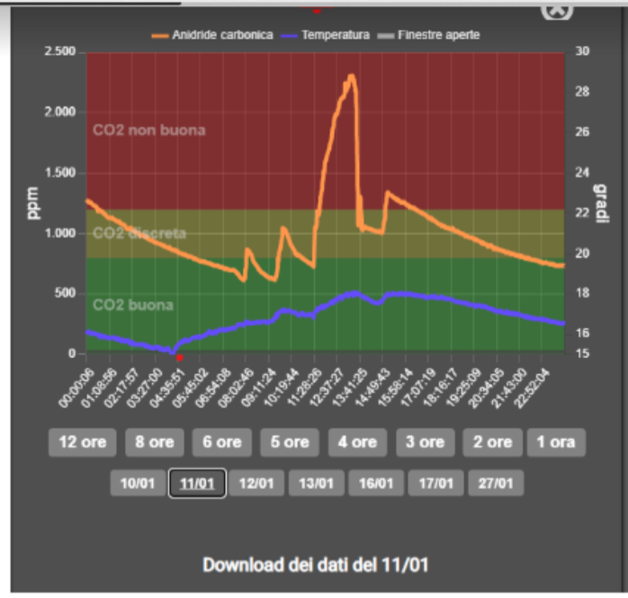

_______________________________________________________________________________________

_______________________________________________________________________________________

_______________________________________________________________________________________

_____________________________________________________________________________________________________________________________________________________________________________________________________________________________________________________________________

Your opinion on the CHANGE Pathway (1 to 5: 1 worst…5 best)

Are the project organization and objectives clear?

What is your personal engagement in the project?

Do you thick that the CHANGE Pathway can have a positive impact on your professional development?

What was your knowledge level before starting the Pathway?

Is the CHANGE Pathway coherent to your studies?

What was the level of your interest in the treated topics?

What is the most interesting topic for you?

Which topic would you like to know more in detail?